**Topics: Descriptive Statistics and Probability**

1. Look at the data given below. Plot the data, find the outliers and find out $μ, σ, σ^{2}$

|  |  |
| --- | --- |
| **Name of company** | **Measure X** |
| Allied Signal | 24.23% |
| Bankers Trust | 25.53% |
| General Mills | 25.41% |
| ITT Industries | 24.14% |
| J.P.Morgan & Co. | 29.62% |
| Lehman Brothers | 28.25% |
| Marriott | 25.81% |
| MCI | 24.39% |
| Merrill Lynch | 40.26% |
| Microsoft | 32.95% |
| Morgan Stanley | 91.36% |
| Sun Microsystems | 25.99% |
| Travelers | 39.42% |
| US Airways | 26.71% |
| Warner-Lambert | 35.00% |

Mean =33.271

Standard deviation = 0.169454

Variance = 0.02871466

Outliers =91.36

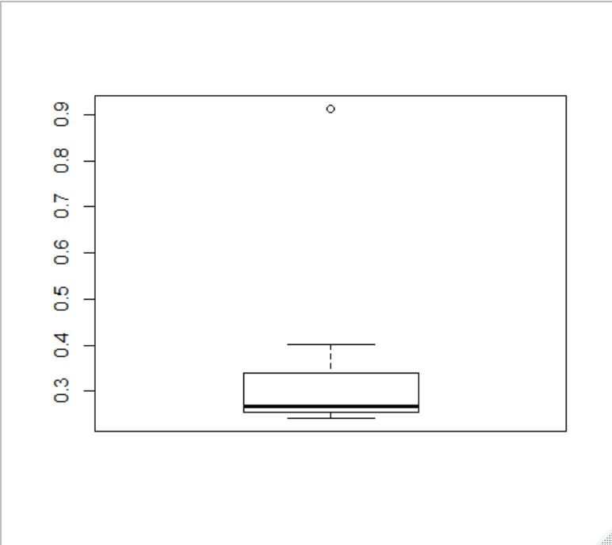



Answer the following three questions based on the box-plot above.

1. What is inter-quartile range of this dataset? (please approximate the numbers) In one line, explain what this value implies.
2. IQR = (12-5) =7 => Here , IQR is equal to median ,half of the data lies in this IQR
3. What can we say about the skewness of this dataset?
4. Positively skewed5
5. If it was found that the data point with the value 25 is actually 2.5, how would the new box-plot be affected?
6. There wont be any outlier
7. There will be decrease in the right skewness



Answer the following three questions based on the histogram above.

1. Where would the mode of this dataset lie?
2. Mode lies between 4 to 9
3. Comment on the skewness of the dataset.
4. Positive skewness or right skewed
5. Suppose that the above histogram and the box-plot in question 2 are plotted for the same dataset. Explain how these graphs complement each other in providing information about any dataset.
6. Boxplot and histogram used to find median ,skewness and outliers
7. We have 25 as outlier and dataset is right skewed
8. AT&T was running commercials in 1990 aimed at luring back customers who had switched to one of the other long-distance phone service providers. One such commercial shows a businessman trying to reach Phoenix and mistakenly getting Fiji, where a half-naked native on a beach responds incomprehensibly in Polynesian. When asked about this advertisement, AT&T admitted that the portrayed incident did not actually take place but added that this was an enactment of something that “could happen.” Suppose that one in 200 long-distance telephone calls is misdirected. What is the probability that at least one in five attempted telephone calls reaches the wrong number? (Assume independence of attempts.)

A) probability of one misdirected call among 200

P(wc) = 1/200 = 0.005

Probability of not wrong call: 1 - P(wc) =1- 1/200 = 0.995

Probability of at least one out of five is a wrong number

= 1 – Probability that all five calls are not wrong numbers

= 1 – (1 – P(wc))^5

= 1 – (1- 0.005)^5

= 1 – 0.975

= round(0.02475)

= 2.5% chance

1. Returns on a certain business venture, to the nearest $1,000, are known to follow the following probability distribution

|  |  |
| --- | --- |
| x | P(x) |
| -2,000 | 0.1 |
| -1,000 | 0.1 |
| 0 | 0.2 |
| 1000 | 0.2 |
| 2000 | 0.3 |
| 3000 | 0.1 |

1. What is the most likely monetary outcome of the business venture?
2. 2000 has 30%
3. Is the venture likely to be successful? Explain
4. The venture may be successful can be said by plotting histogram plot the hist is positively skewed
5. The venture is succesfull becoz the probabilitity of return is 60%
6. What is the long-term average earning of business ventures of this kind? Explain
7. Average =800
8. What is the good measure of the risk involved in a venture of this kind? Compute this measure

Variance =3500000

Std dev =1870.829

the venture is risky since the std dev is high